ACTIVITY: ABC’s in Glitter Salt

Domain assigned: Cognitive Literacy
Activity By: Madison Leintz, Sydney Arman, Katie Baumgartner, Kayla Haak, & Lexi Peterson
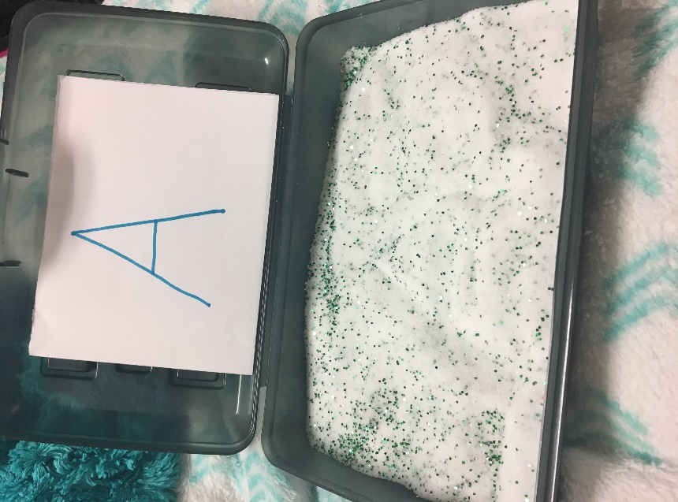

MATERIALS:
- Pencil Boxes (10)
- Salt
- Glitter
- Notecards with alphabet written on them
- Dr. Seuss ABC Book

TARGETED SKILLS (include domains addressed by the targeted skills):
- Cognitive Literacy
- Sensory
- Letter & Letter Sound Recognition
- Fine Motor

IDEAS FOR DIFFERENTIATION:

Modifications/Adaptations:
- Add Lower Case Letters
- Give children a stick with an eraser on the end if they do not want to touch the salt
- Give children a larger stick so that they can grasp on easier
- Only give children the letters in their name or just a few letters at a time

Extensions or Other Ideas to Use This Activity:
- Write full words in the box
- Practice shapes
- Practice numbers
- Practice writing name
- Use salt just for sensory purposes

